Name: G R Aakaash Slot: A
Reg No: 192412068 Course faculty: Sathish,K

EXP-10: 5G Network Slicing Environment Using MATLAB

Objective – 1: Analyze the creation and allocation of multiple network slices in a 5G network using MATLAB. Observe how different slices can be configured to support diverse service requirements and applications.

CODE: clc;
clear;
close all;
slices = {'eMBB','URLLC','mMTC','Private','IoT'};

count = [1 1 1 1 1]; % One instance of each network slice
figure
bar(count)
grid on
set(gca,'XTickLabel',slices)
xlabel('Network Slice Type')
ylabel('Number of Network Slices')
title('Number of Configured 5G Network Slices')
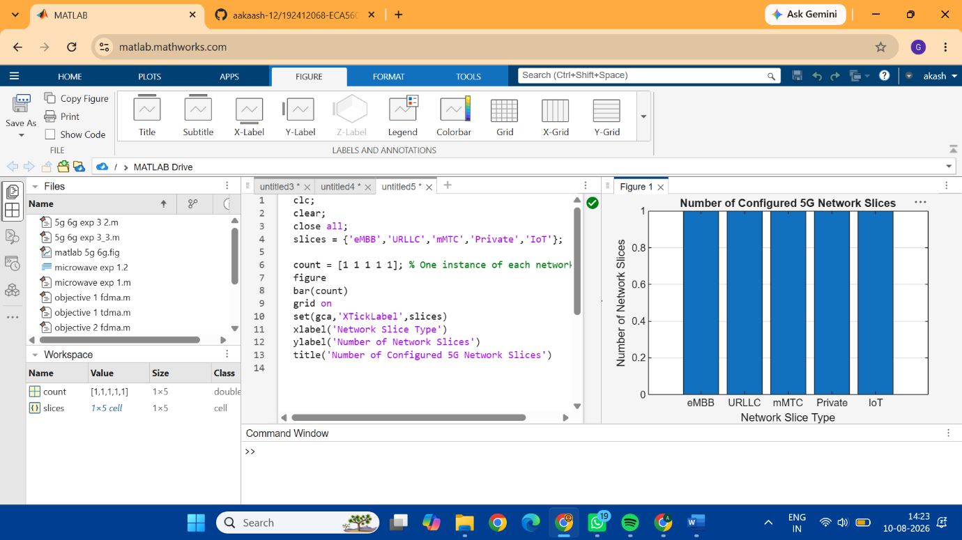

Objective-2: Compare the utilization of different network slices using MATLAB. Analyze how efficiently network resources are allocated and utilized across multiple slices.

CODE: clc;
clear;
close all;
slices = categorical({'eMBB','URLLC','mMTC','Private','IoT'});
utilization = [85 70 60 75 50];

figure;
bar(slices, utilization);
grid on;
xlabel('Network Slice Type');
ylabel('Slice Utilization (%)');
title('Slice Utilization in 5G Network Slicing');
ylim([0 100]);
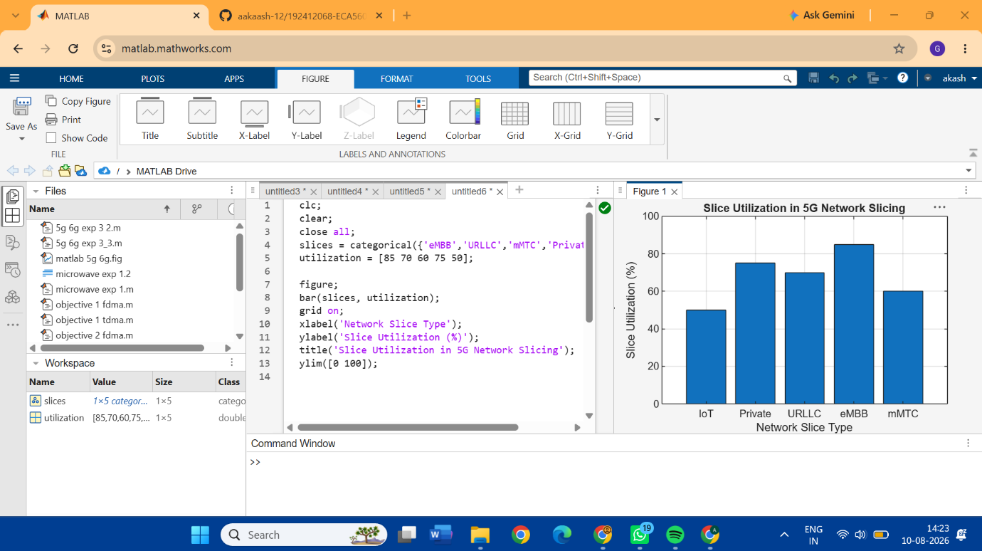
OBJECTIVE-3: Compare the end-to-end latency of different network slices using MATLAB. Observe how latency varies depending on the service requirements of each slice.
CODE: clc;
clear;
close all;
slices = [1 2 3 4 5];
latency = [25 5 40 15 60];
figure;
plot(slices, latency, '-o','LineWidth',2,'MarkerSize',8);
grid on;

xticks(slices);
xticklabels({'eMBB','URLLC','mMTC','Private','IoT'});
xlabel('Network Slice Type');
ylabel('End-to-End Latency (ms)');
title('5G Network Slicing: End-to-End Latency');
ylim([0 70]);
